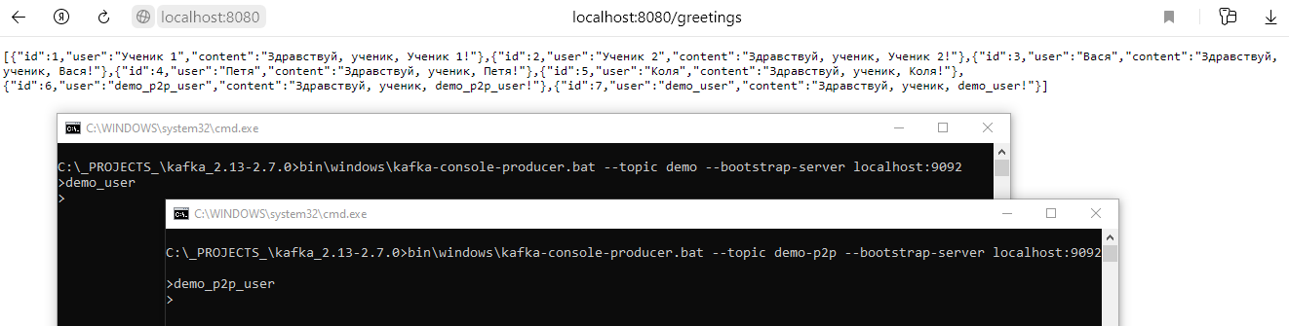

2021-04-15 20:20:43.149 DEBUG 9568 --- [container-0-C-1] r.leo.springdemo.events.MessageListener : Сообщение получателю : demo_p2p_user

2021-04-15 20:20:53.633 DEBUG 9568 --- [container-0-C-1] r.leo.springdemo.events.MessageListener : Сообщение всем : demo_user

2021-04-15 20:21:06.647 INFO 9568 --- [nio-8080-exec-7] ru.leo.springdemo.log.LoggingAspect : Вызван метод greetings параметры: {}

2021-04-15 20:21:06.649 INFO 9568 --- [nio-8080-exec-7] ru.leo.springdemo.log.LoggingAspect : Результат: [{"id":1,"user":"Ученик 1","content":"Здравствуй, ученик, Ученик 1!"},{"id":2,"user":"Ученик 2","content":"Здравствуй, ученик, Ученик 2!"},{"id":3,"user":"Вася","content":"Здравствуй, ученик, Вася!"},{"id":4,"user":"Петя","content":"Здравствуй, ученик, Петя!"},{"id":5,"user":"Коля","content":"Здравствуй, ученик, Коля!"},{"id":6,"user":"demo_p2p_user","content":"Здравствуй, ученик, demo_p2p_user!"},{"id":7,"user":"demo_user","content":"Здравствуй, ученик, demo_user!"}]